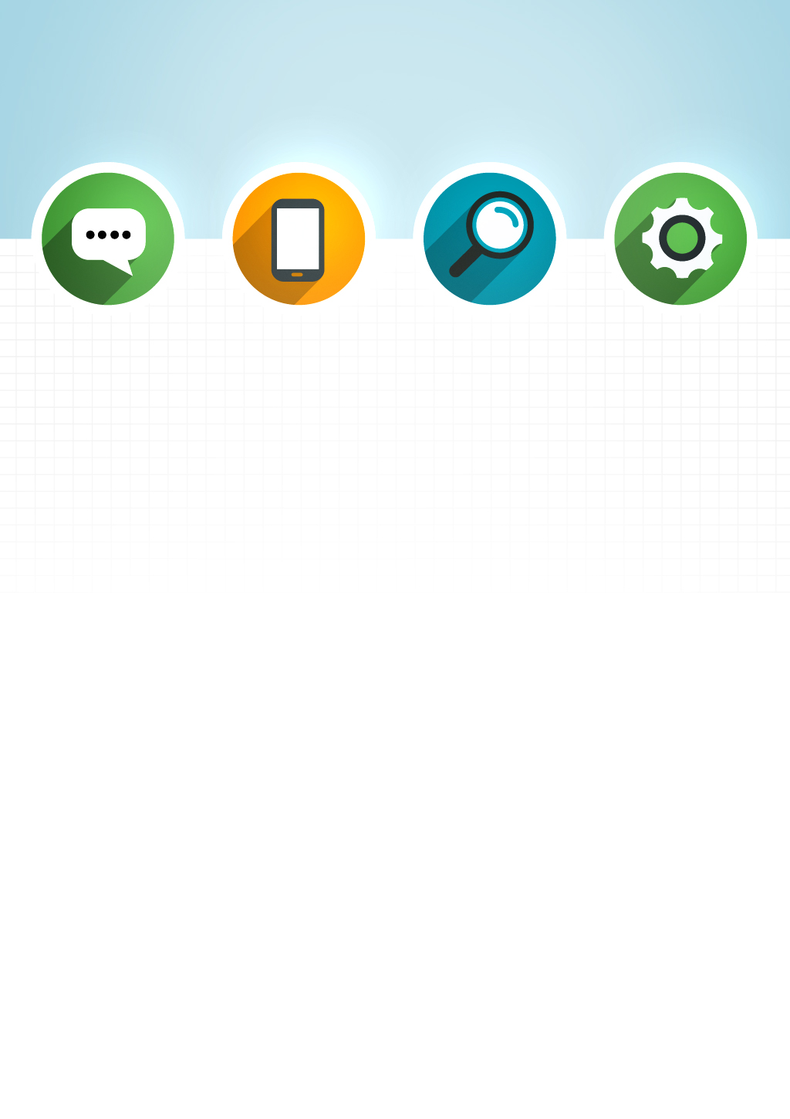



Website organic shop

Member

**Nguyễn Vũ Khang CE140224**

Hứa Quốc Vinh CE140143

Nguyễn Ngọc Anh Tú CE140381

Mentor: Lương Hoàng Hướng



Table of Contents

Website organic shop 1

I. Introduction 3

**1.** **Problem definition** 3

**2.** **Customer Requirement Specification** 4

**a)** **Inteface requirements** 4

**b)** **Functional requirements** 4

**c)** **Customer’s requirement** 4

**3.** **Hardware and Software Requirement** 5

**a)** **Hardware** 5

**b)** **Software** 6

II. Role, Github, Gannt diagram, meeting schedule and checklist 7

**1.** **Role** 7

**2.** **Link Github** 7

**3.** **Grantt diagram** 8

**4.** **Meeting schedule** 9

**5.** **Checklist** 10

III. Theory 11

**1.** **Introduce to JSP** 11

**2.** **Introduction to MVC in JSP** 12

**3.** **Introduction to AJAX** 13

**4.** **Introduction to Servlet** 14

IV. Architecture System 15

**1.** **Client - Server architecture** 15

**2.** **Entity Relationship Diagram** 16

**3.** **Class Diagram** 17

**4.** **Use-case Diagram** 18

**5.** **Activity Diagram** 20

**6.** **DFD** 21

**a)** **Data flow diagram symbol** 21

**b)** **Level 0** 22

**c)** **Level 1** 23

V. Functions, User Interfaces and Flow chart 25

**1.** **Functions** 25

**a)** **User Features** 25

**b)** **Admin Features** 25

**2.** **User Interface** 26

VI. Conclusion 30

# Introduction

1. **Problem definition**

Today, online selling has been widely popular in the world, this form of sale not only helps distributors quickly and fully product, saving costs, travel time. The website is based on a traditional shop and an online store. Instead of a showroom, our website now displays all the products and customers can order them anytime and anywhere. Along with a friendly interface, the website will help customers easily select and buy the products they like. In addition, coming to our Website, you will enjoy the taste of extremely clean food, and some fresh, clean food, cheap and with the enthusiastic support of the staff.

The entire process is virtually done and there is no need for the person to be physically present at the place at the moment. It is an extensively fuss-free process which has saved a lot of precious time of people who are busy with their daily life.

"Say no to fake, shoddy food. Protection of consumer rights. Welcome to us KVT is pleased to welcome you"



## **Customer Requirement Specification**

This application is simulation for Online shopping website build and the user can search for the products and buy them online as a best practise:

1. **Inteface requirements**

* There are additional promotional images, along with notifying customers when adding to the cart
* Web operations must be familiar and easy to use with users, allowing operation by both mouse and keyboard.
* Has illustrative images, clear and detailed content and well-organized content structure.
* Beautiful and user friendly interface.

1. **Functional requirements**

* Can add, edit, delete, search products quickly and easily.
* Have a function of history order management, user management, product management, add slider for web advertisement management.
* Registration, login, and logout functions.
* Manipulate the cart, payment.
* Scratch card for user and admin can scratch card management
* High security, maintainability, and easy system development

1. **Customer’s requirement**

* Easy to find, fast, accurate search by name, search by price, and search by category for product
* Can check infomation account and edit it, see the products in the cart.
* Payment is quick, easy and confidential.



1. **Hardware and Software Requirement**
2. **Hardware**

* **Servers**

|  |  |
| --- | --- |
| Hardware requirement  (minimal configuration) | Hardware requirement  (recommended configuration) |
| * CPU: 500 MHz processor * RAM: 2GB RAM * HDD: 500MB of free disk space | * **CPU:** 4GHZ Dual Core or 3GHZ processor * **RAM:** 4GB RAM * **HDD:** 1GB of free disk space |

* **Client**

|  |  |
| --- | --- |
| Hardware requirement  (minimal configuration) | Hardware requirement  (recommended configuration) |
| * CPU: 500 MHz processor * RAM: 2GB RAM * HDD: 500MB of free disk space | * **CPU:** 4GHZ Dual Core or 3GHZ processor * **RAM:** 4GB RAM * **HDD:** 1GB of free disk space |

1. **Software**

* **Server**

|  |
| --- |
| Software requirement |
| * Window 7 or higher * JRE 1.7 or higher |

* **Client**

|  |
| --- |
| Software requirement |
| * Window 7 or higher * JRE 1.7 or higher |

# Role, Github, Gannt diagram, meeting schedule and checklist

1. **Role**

|  |  |  |  |  |
| --- | --- | --- | --- | --- |
| No | Name of member | Role | Responsibility | Note |
| 1 | Khang | Leader | Assignment of tasks | Complete |
| 2 | Khang, Tú, Vinh | Analyst | Define problem, input, output, process | Complete |
| 3 | Khang, Tú, Vinh | Design | Design interface | Complete |
| 4 | 3-9 Khang  1,2,10 Tú | Coder | **User Features:**   1. User can sign up for the first time 2. User can sign in. 3. User can view products 4. User can add products to cart 5. User can delete products from cart 6. User can decrease quantity of a product in the cart. 7. User search for products 8. User can charge his balance 9. User can pay cash to get the product 10. User can logout from the site. | Complete |
| 5 | 1 Khang  2-9 Vinh  10-14 Tú | Coder | Admin Features:   1. Admin can view products 2. Admin can add product 3. Admin can delete product 4. Admin can edit product 5. Admin can add products to the slider 6. Admin can add scratch cards 7. Admin can view history 8. Admin can add new category 9. Admin can delete category 10. Admin can add ads 11. Admin can remove ads 12. Admin can view users 13. Admin can edit users profiles 14. Admin can view the history | Complete |
| 10 | Khang, Tú, Vinh | Tester | Testing all functions for project | Complete |
| 11 | Khang, Tú, Vinh | Maintenaner | Check and backup data | Complete |

1. **Link Github**

https://github.com/nguyenvukhang2000/KVTGroup_PRJ321_SE1403_Website

1. **Grantt diagram**

**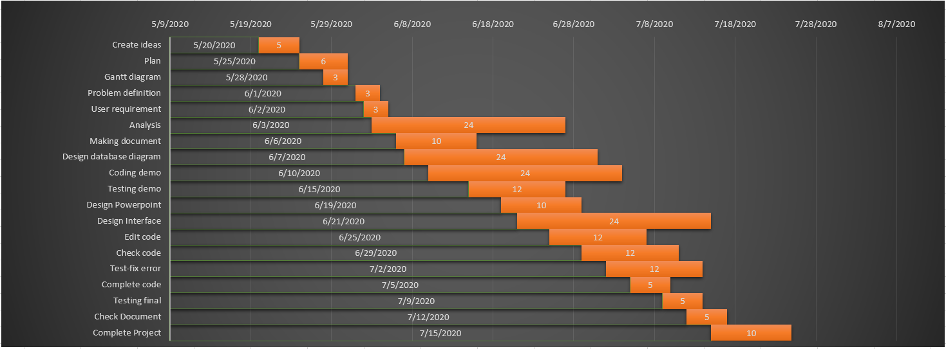***s*

**Figure 1:** *Grantt diagram*

1. **Meeting schedule**

|  |  |  |  |  |  |
| --- | --- | --- | --- | --- | --- |
| No. | Date | Form | Place | Members | Content |
| 1 | 07/06/2020 | Offline | FPT University | Khang, Vinh Tú | Progress reports |
| 2 | 21/06/2020 | Online | Teamviewer | Khang, Vinh Tú | Progress reports |
| 3 | 26/06/2020 | Offline | FPT University | Khang, Vinh Tú | Progress reports |
| 4 | 01/07/2020 | Online | Teamviewer | Khang, Vinh Tú | Progress reports |
| 5 | 08/07/2020 | Offline | FPT University | Khang, Vinh Tú | Progress reports |
| 6 | 14/07/2020 | Offline | FPT University | Khang, Vinh Tú | Progress reports |
| 7 | 15/07/2020 | Offline | FPT University | Khang, Vinh Tú | Progress reports |

1. **Checklist**

|  |  |  |  |  |  |  |  |
| --- | --- | --- | --- | --- | --- | --- | --- |
| No. | Document Name | Date  (MM/dd/yyyy) | Estimated number of hours completed | Complete  Time  (MM/dd/yyyy) | Real  time | Member names | Note |
| 1 | Create ideas | 5/20/2020 | 5 | 22:00  5/20/2020 | 3 | Khang, Tú, Vinh | Complete |
| 2 | Plan | 5/25/2020 | 6 | 14:00  5/26/2020 | 4 | Khang, Tú, Vinh | Complete |
| 3 | Gannt diagram | 5/28/2020 | 3 | 20:00  5/29/2020 | 3 | Khang | Complete |
| 4 | Problem definition | 6/1/2020 | 3 | 16:00  6/1/2020 | 3 | Tú | Complete |
| 5 | User requirement | 6/2/2020 | 3 | 23:00  6/2/2020 | 3 | Khang, Vinh | Complete |
| 6 | Analysis | 6/3/2020 | 24 | 23:00  6/5/2020 | 24 | Khang, Vinh, Tú | Complete |
| 7 | Making document | 6/6/2020 | 10 | 20:00  6/7/2020 | 9 | Khang, Vinh, Tú | Complete |
| 8 | Design database diagram | 6/7/2020 | 24 | 22:30  6/9/2020 | 24 | Khang, Vinh, Tú | Complete |
| 9 | Coding demo | 6/10/2020 | 24 | 23:00  6/13/2020 | 24 | Khang, Vinh, Tú | Complete |
| 10 | Testing demo | 6/15/2020 | 12 | 15:00  6/18/2020 | 13 | Khang, Vinh, Tú | Complete |
| 11 | Design Powerpoint | 6/19/2020 | 10 | 20:00  6/20/2020 | 8 | Khang, Vinh, Tú | Complete |
| 12 | Design Interface | 6/21/2020 | 24 | 23:00  6/24/2020 | 25 | Khang, Vinh, Tú | Complete |
| 13 | Edit code | 6/25/2020 | 12 | 22:00  6/28/2020 | 12 | Khang, Vinh, Tú | Complete |
| 14 | Check code | 6/29/2020 | 12 | 23h15  7/1/2020 | 13 | Khang, Vinh, Tú | Complete |
| 15 | Test-fix error | 7/2/2020 | 12 | 19:00  7/4/2020 | 11 | Khang, Vinh, Tú | Complete |
| 16 | Complete code | 7/5/2020 | 5 | 22:30  7/8/2020 | 5 | Khang, Vinh, Tú | Complete |
| 17 | Testing final | 7/10/2020 | 6 | 23:00  7/14/2020 | 6 | Khang, Vinh, Tú | Complete |
| 18 | Check Document | 7/15/2020 | 5 | 21:30  7/16/2020 | 4 | Khang, Vinh, Tú | Complete |
| 19 | Complete Project | 7/17/2020 | 10 | 23:45  7/23/2020 | 10 | Khang, Vinh, Tú | Complete |

# Theory

## **Introduce to JSP**

Java Server Pages (JSP) is a server-side programming technology that enables the creation of dynamic, platform-independent method for building Web-based applications. JSP have access to the entire family of Java APIs, including the JDBC API to access enterprise databases. This tutorial will teach you how to use Java Server Pages to develop your web applications in simple and easy steps.

**Advantages**

* Performance is significantly better because JSP allows embedding Dynamic Elements in HTML Pages itself instead of having separate CGI files.
* JSP are always compiled before they are processed by the server unlike CGI/Perl which requires the server to load an interpreter and the target script each time the page is requested.
* JavaServer Pages are built on top of the Java Servlets API, so like Servlets, JSP also has access to all the powerful Enterprise Java APIs, including **JDBC, JNDI, EJB, JAXP,** etc.
* JSP pages can be used in combination with servlets that handle the business logic, the model supported by Java servlet template engines.

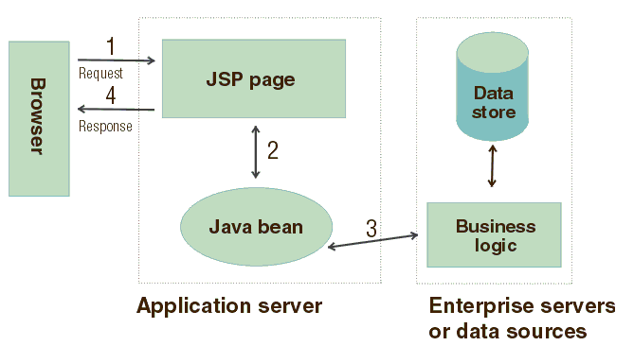

**Figure 2:** *Example JSP connect browser and data store*

## **Introduction to MVC in JSP**

**MVC** stands for Model View and Controller. It is a **design pattern** that separates the business logic, presentation logic and data.

* M stands for Model
* V stands for View
* C stands for controller.

**Model Layer**

* This is the data layer which consists of the business logic of the system.
* It consists of all the data of the application
* It also represents the state of the application.
* It consists of classes which have the connection to the database.
* The controller connects with model and fetches the data and sends to the view layer.
* The model connects with the database as well and stores the data into a database which is connected to it.

**View Layer**

* This is a presentation layer.
* It consists of HTML, JSP, etc. into it.
* It normally presents the UI of the application.
* It is used to display the data which is fetched from the controller which in turn fetching data from model layer classes.
* This view layer shows the data on UI of the application.

**Controller Layer**

* It acts as an interface between View and Model.
* It intercepts all the requests which are coming from the view layer.
* It receives the requests from the view layer and processes the requests and does the necessary validation for the request.
* This requests is further sent to model layer for data processing, and once the request is processed, it sends back to the controller with required information and displayed accordingly by the view.

**Advantages**

* Easy to maintain.
* Easy to extend.
* Easy to test.
* Navigation control is centralized.

## **Introduction to AJAX**

AJAX = Asynchronous JavaScript and XML.

AJAX is not a programming language.

AJAX just uses a combination of:

* A browser built-in **XMLHttpRequest** object (to request data from a web server)
* JavaScript and HTML DOM (to display or use the data)

AJAX allows web pages to be updated asynchronously by exchanging data with a web server behind the scenes. This means that it is possible to update parts of a web page, without reloading the whole page.

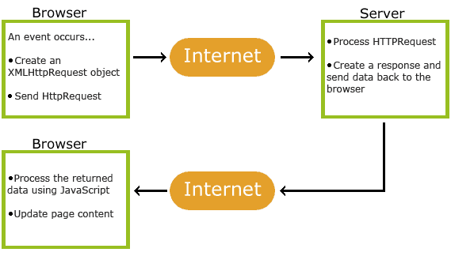

**Figure 3:** *Example use AJAX*

## **Introduction to Servlet**

**Servlet** technology is used to create a web application (resides at server side and generates a dynamic web page).

**Servlet** technology is robust and scalable because of java language. Before Servlet, CGI (Common Gateway Interface) scripting language was common as a server-side programming language. However, there were many disadvantages to this technology. We have discussed these disadvantages below.

There are many interfaces and classes in the Servlet API such as Servlet, GenericServlet, HttpServlet, ServletRequest, ServletResponse, etc.

**Servlet can be described in many ways, depending on the context**.

* Servlet is a technology which is used to create a web application.
* Servlet is an API that provides many interfaces and classes including documentation.
* Servlet is an interface that must be implemented for creating any Servlet.
* Servlet is a class that extends the capabilities of the servers and responds to the incoming requests. It can respond to any requests.
* 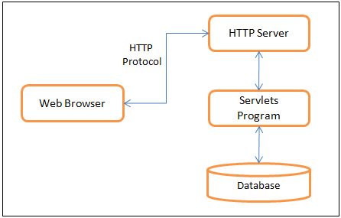Servlet is a web component that is deployed on the server to create a dynamic web page.

**Figure 4:** *Example of Servlet*

# Architecture System

1. **Client - Server architecture**

A Client-Server Architecture consists of two types of components: clients and servers. A server component perpetually listens for requests from client components. When a request is received, the server processes the request, and then sends a response back to the client. Servers may be further classified as stateless or stateful. Clients of a stateful server may make composite requests that consist of multiple atomic requests. This enables more conversational or transactional interactions between client and server. To accomplish this, a stateful server keeps a record of the requests from each current client. This record is called a session.

In order to simultaneously process requests from multiple clients, a server often uses the Master-Slave Pattern. In this case, the Master perpetually listens for client requests. When a request is received, the master creates a slave to processes the request and then resumes listening. Meanwhile, the slave performs all subsequent communication with the client.

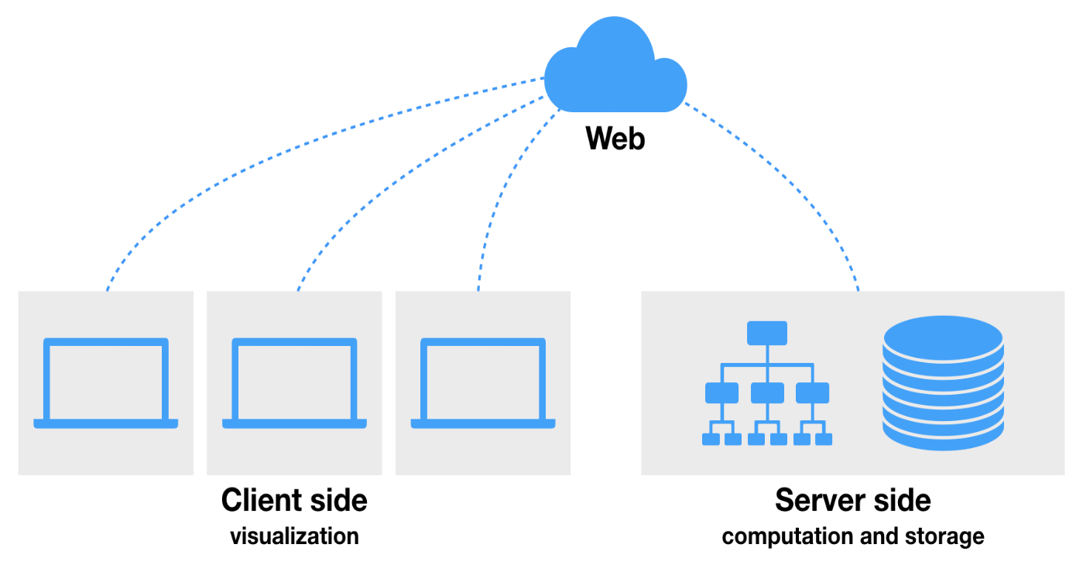**Figure 4:** *Client-Server Architectures*

1. **Entity Relationship Diagram**

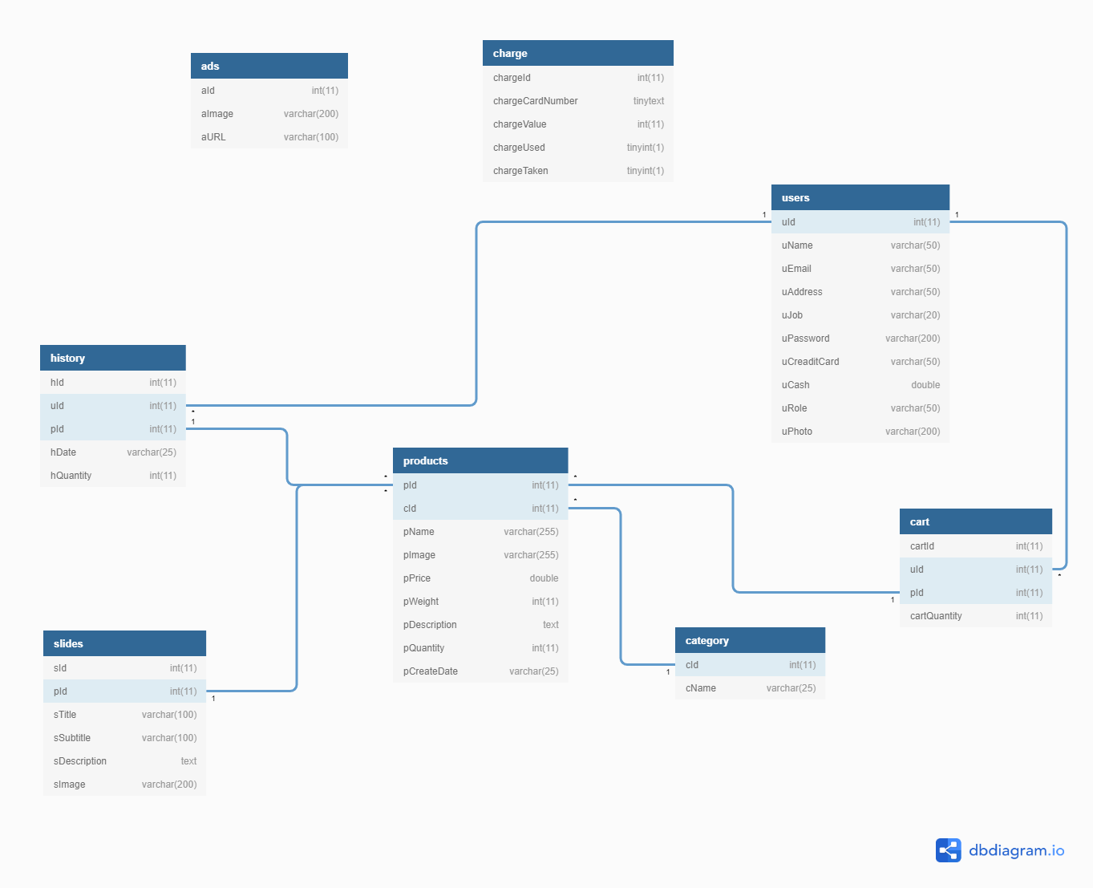

**Figure 5:** *Database diagram of website organic shop*

1. **Class Diagram**

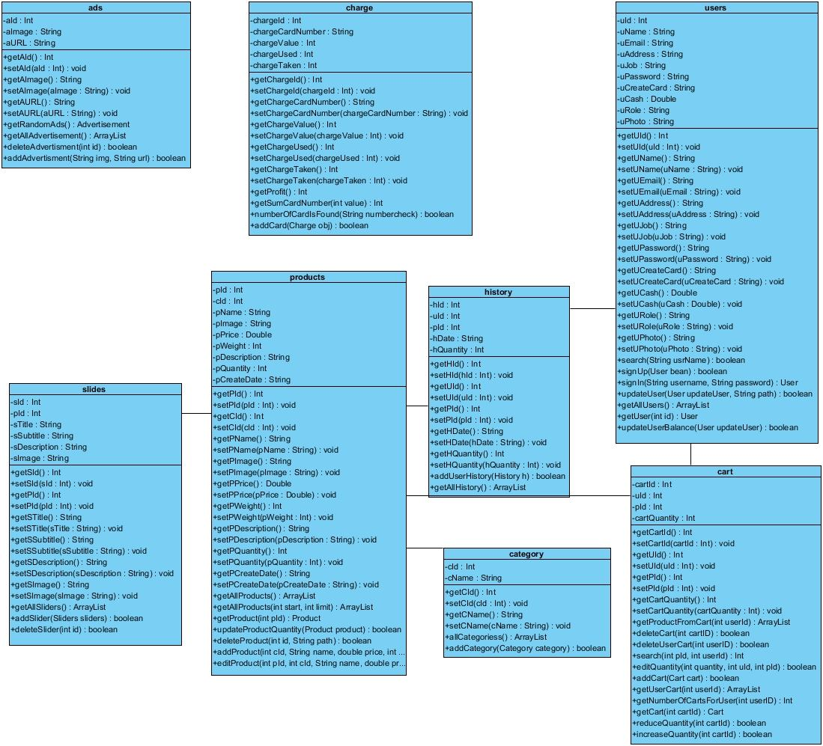

**Figure 5:** *Class diagram of website organic shop*

1. **Use-case Diagram**

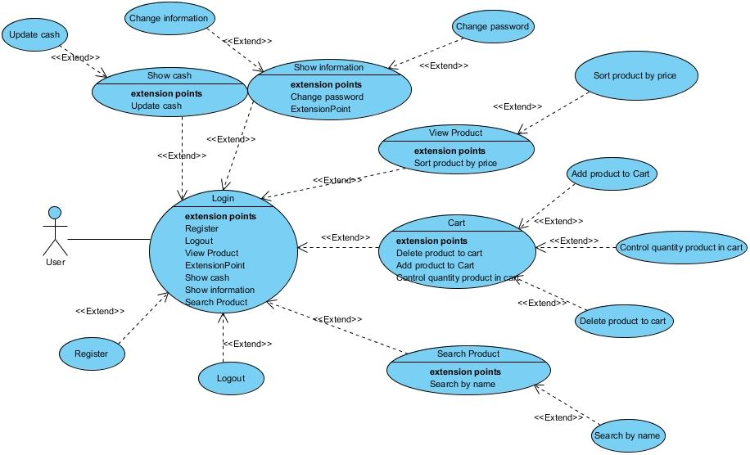

**Figure 7:** *Users use-case diagram*

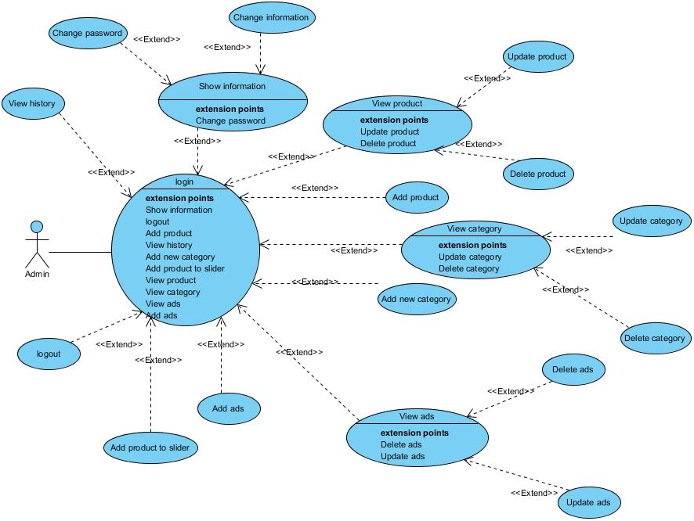

**Figure 8:** *Admin use-case diagram*

1. **Activity Diagram**

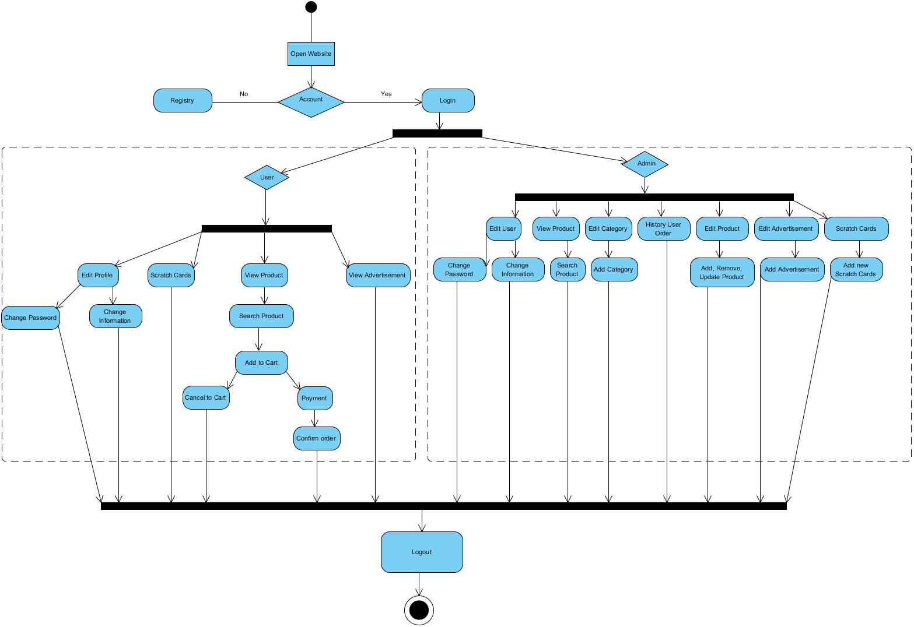

**Figure 9:** *Activity diagram*

1. **DFD**
   * + 1. **Data flow diagram symbol**

|  |  |
| --- | --- |
| Symbol | Description |
|  | **Data Flow:** Data flow are pipelines through the packets of information flow |
|  | **Process:** A Process or task performed by the system |
|  | **Entity:** Entity are object of the system. A source or destination data of a system |
|  | **Data Store:** A place where data to be stored |

**Figure 10:** *Data flow diagram symbol*

* + - 1. **Level 0**

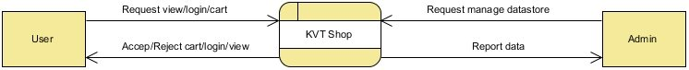

**Figure 11:** *Level 0*

* + - 1. **Level 1**

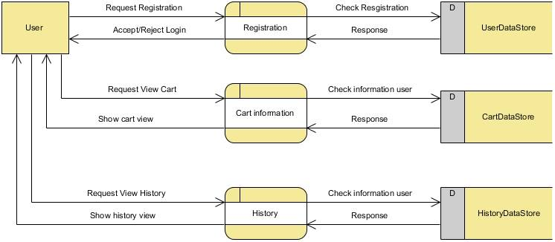

**Figure 12:** *User Level 1*

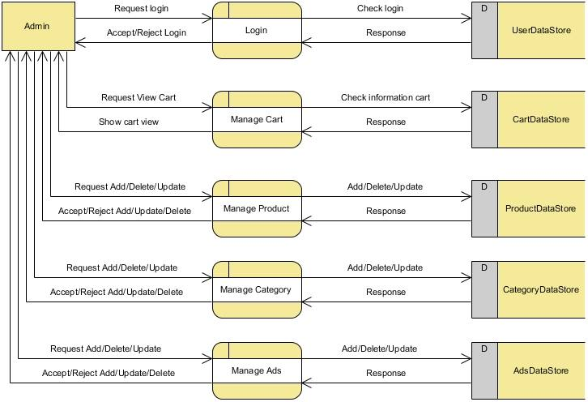

**Figure 13:** *Admin Level 1*

1. **Functions, User Interfaces and Flow chart**
   * + 1. **Functions**
2. **User Features**

* **User can change information**
* **User can change password**
* User can sign up for the first time
* User can sign in.
* User can view products
* User can add products to cart
* User can delete products from cart
* User can decrease quantity of a product in the cart.
* User search for products
* User can charge his balance
* User can pay cash to get the product
* User can logout from the site.

1. **Admin Features**

* **Admin can login**
* **Admin can logout**
* Admin can view products
* Admin can add product
* Admin can delete product
* Admin can edit product
* Admin can add products to the slider
* Admin can add scratch cards
* Admin can view history
* Admin can add new category
* Admin can delete category
* Admin can add ads
* Admin can remove ads
* Admin can view users
* Admin can edit users profiles
  + - 1. **User Interface**

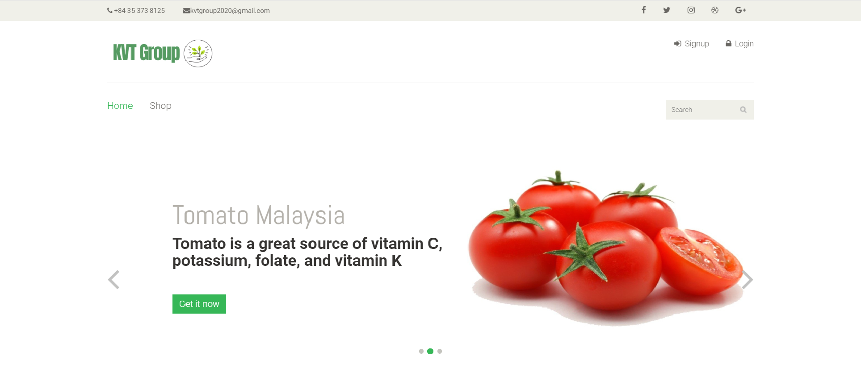

**Figure 14:** *Home page*

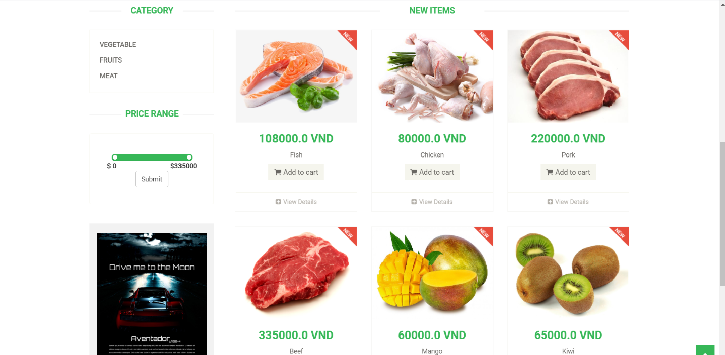

**Figure 15**: *Shop page*

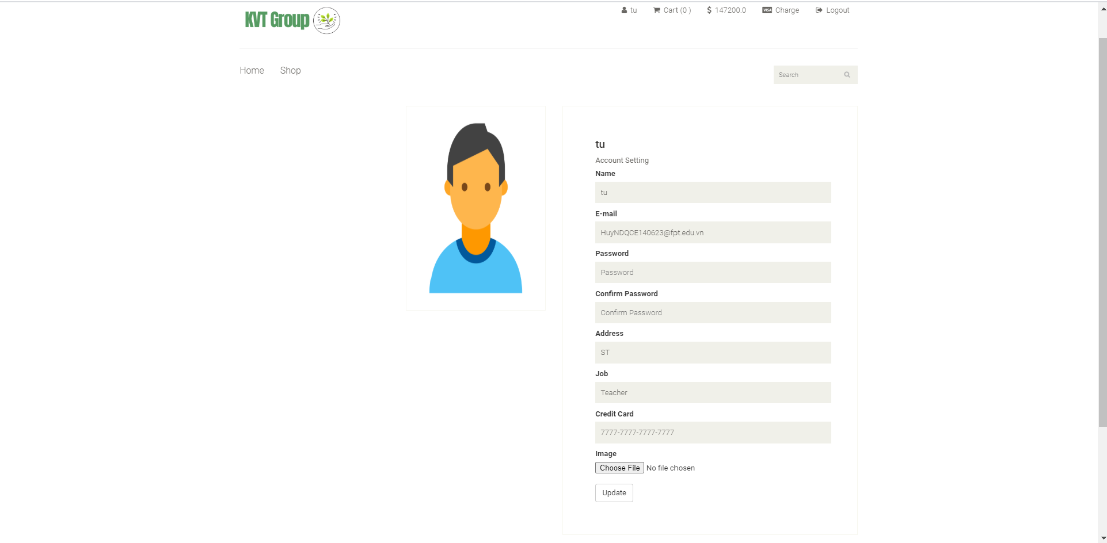

**Figure 16**: *Update info user page*

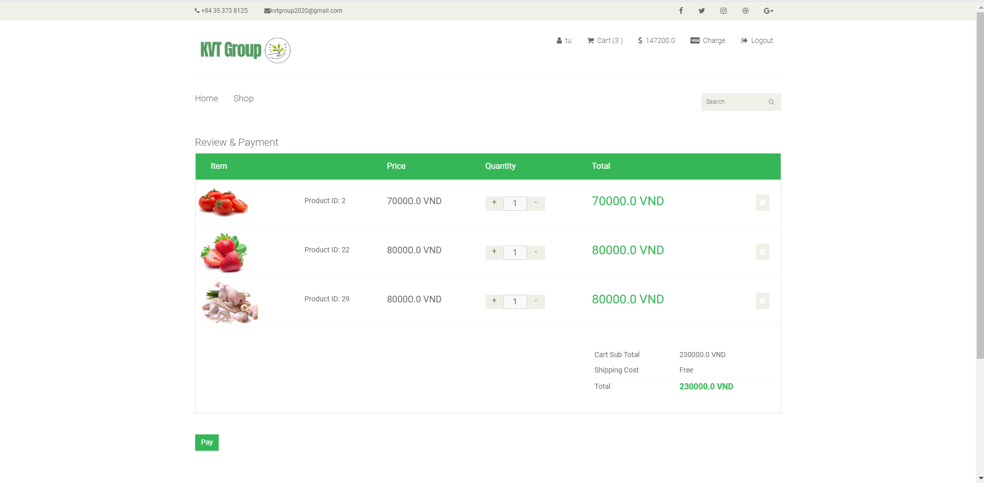

**Figure 17**: *Cart page*

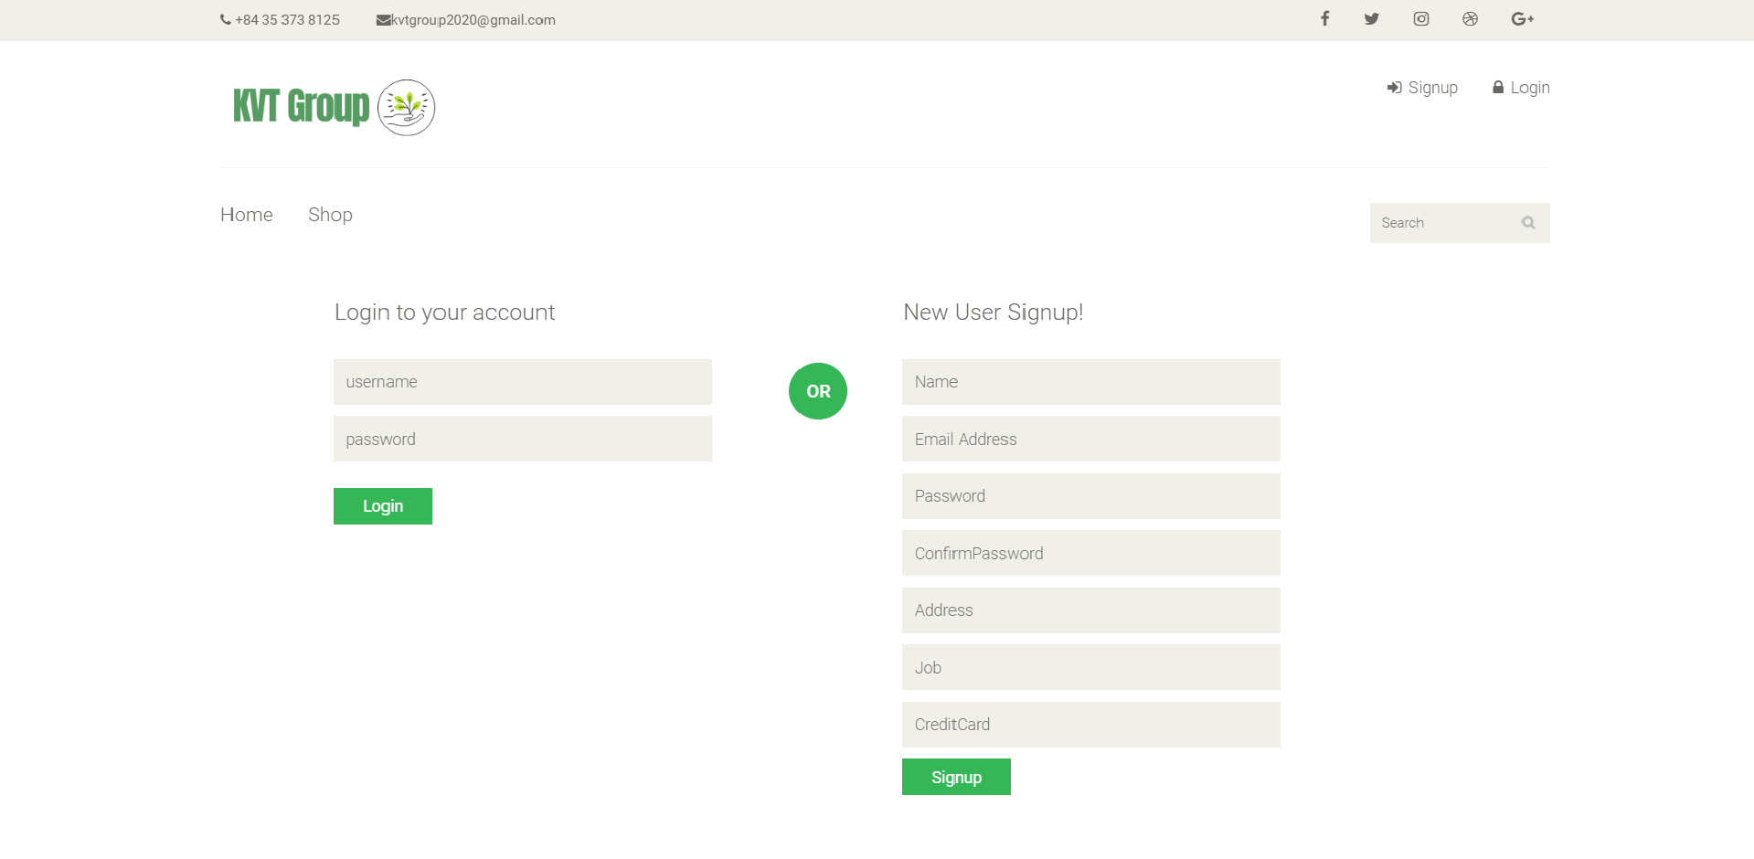

**Figure 18**: *Login page*

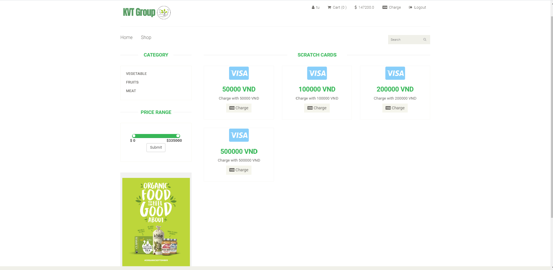

**Figure 19**: *Cratch card page*

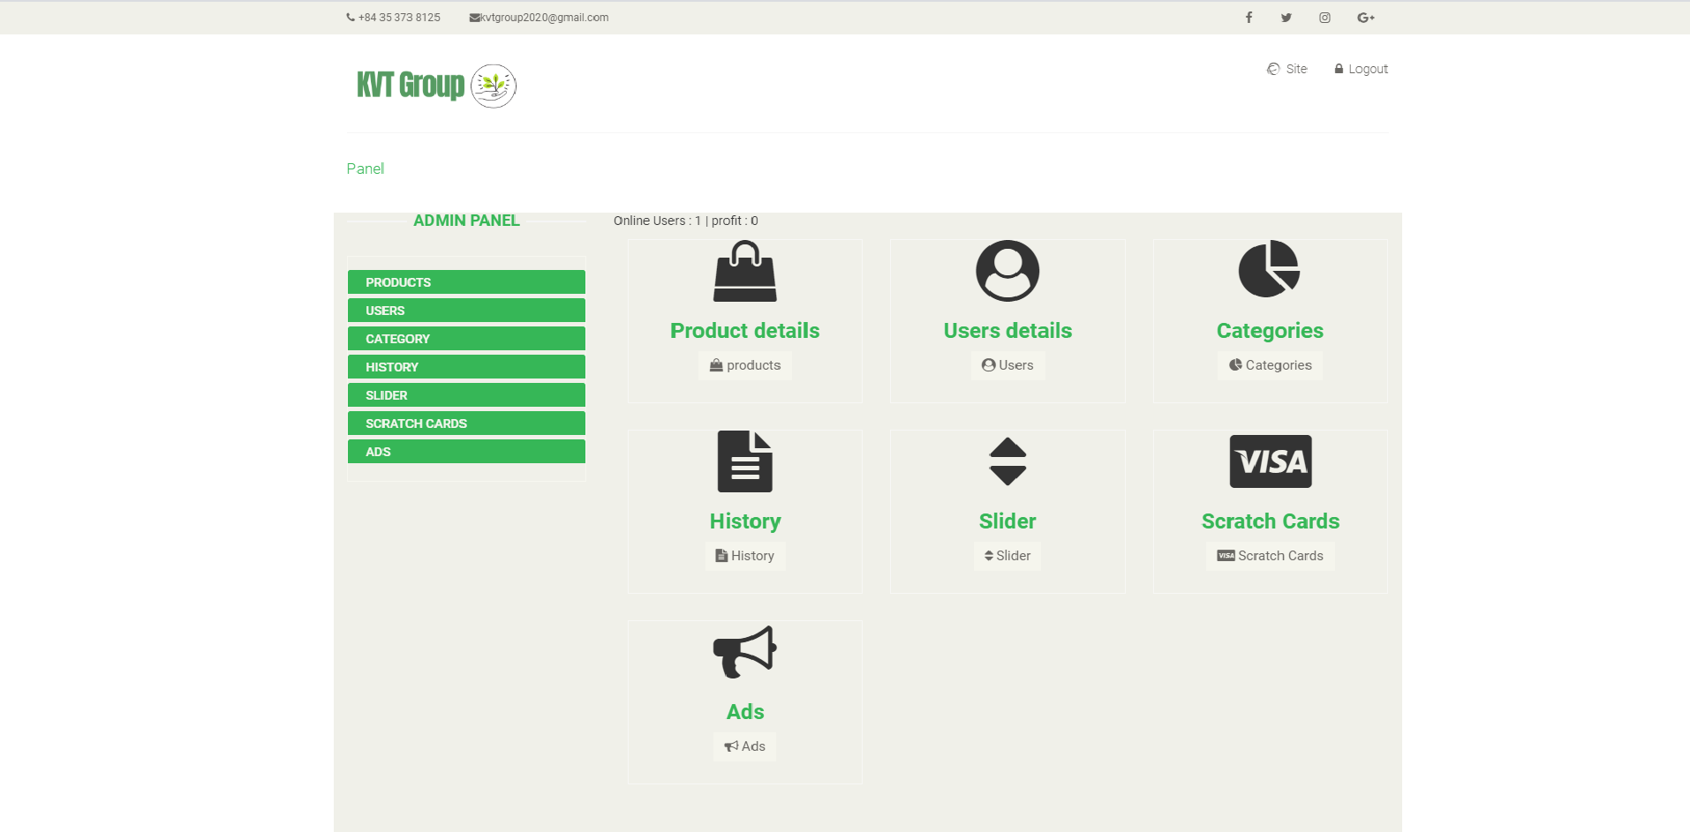

**Figure 20**: *Admin home page*

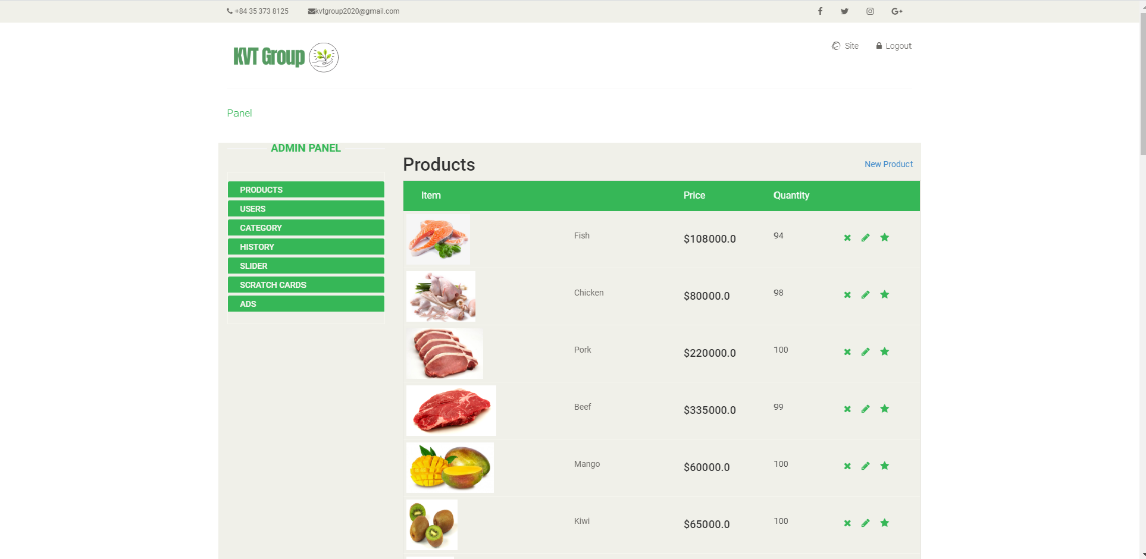

**Figure 21**: *Admin manage products*

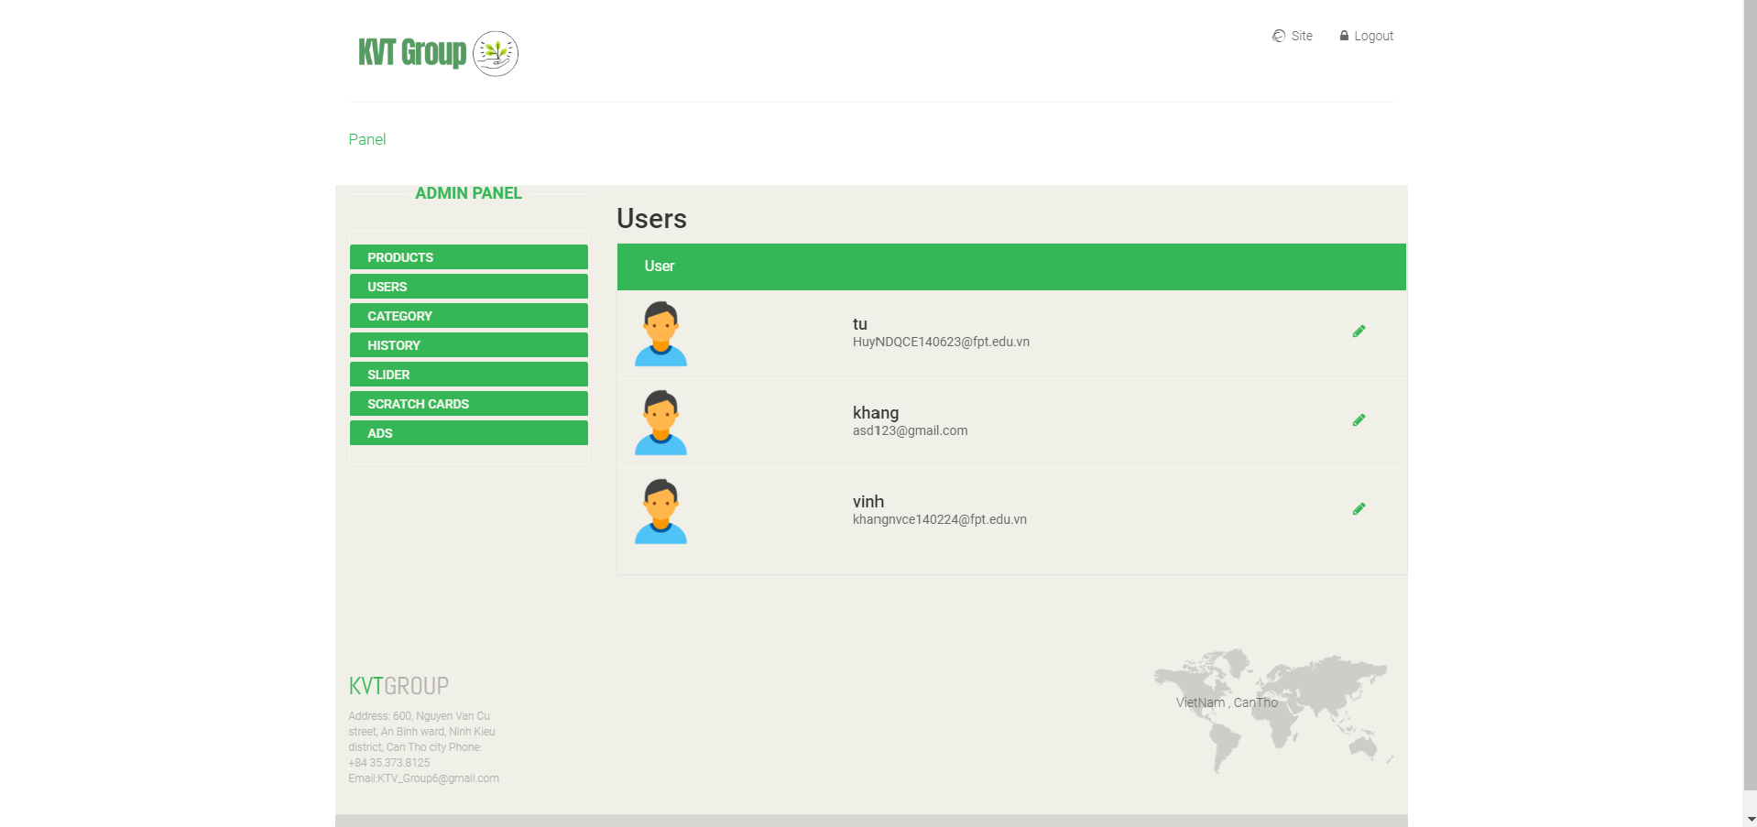

**Figure 22**: *Admin manage users*

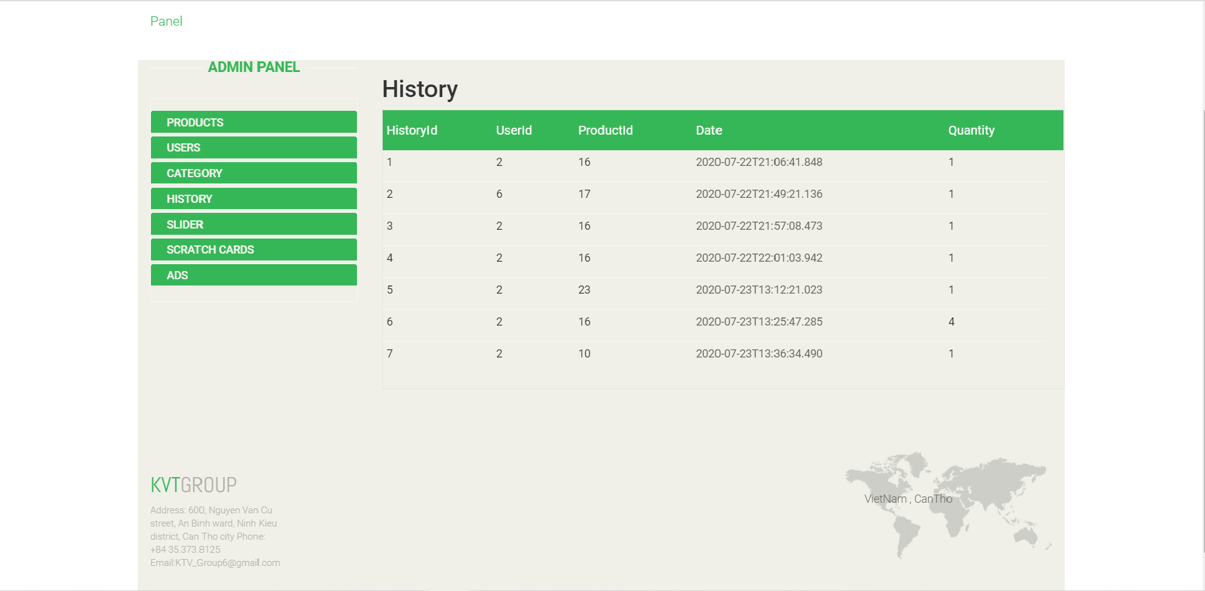

**Figure 23**: *Admin manage history*

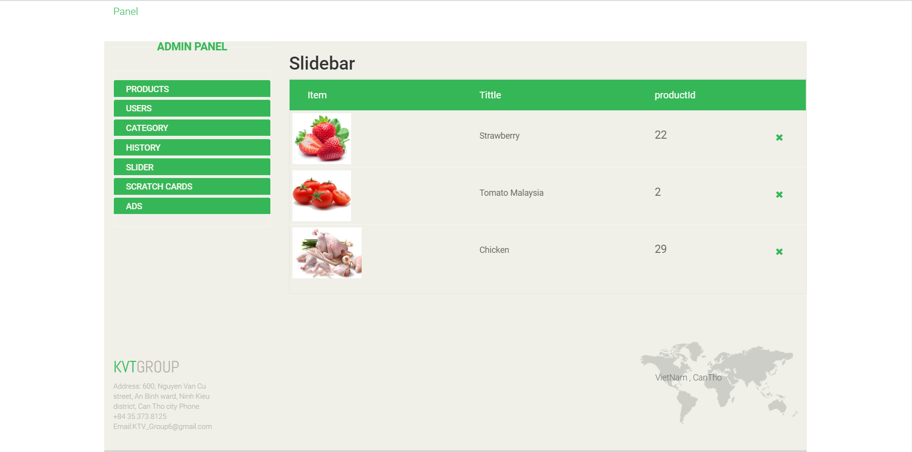

**Figure 24**: *Admin manage slider*

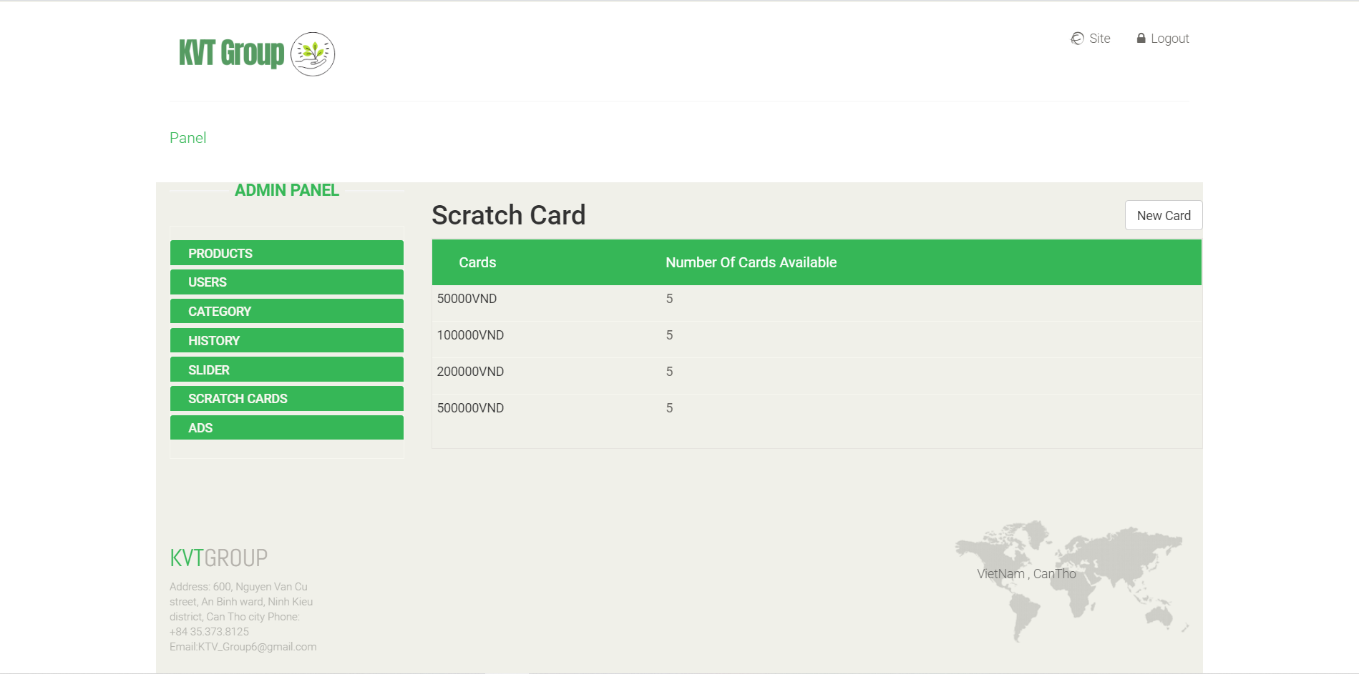

**Figure 24**: *Admin manage cards*

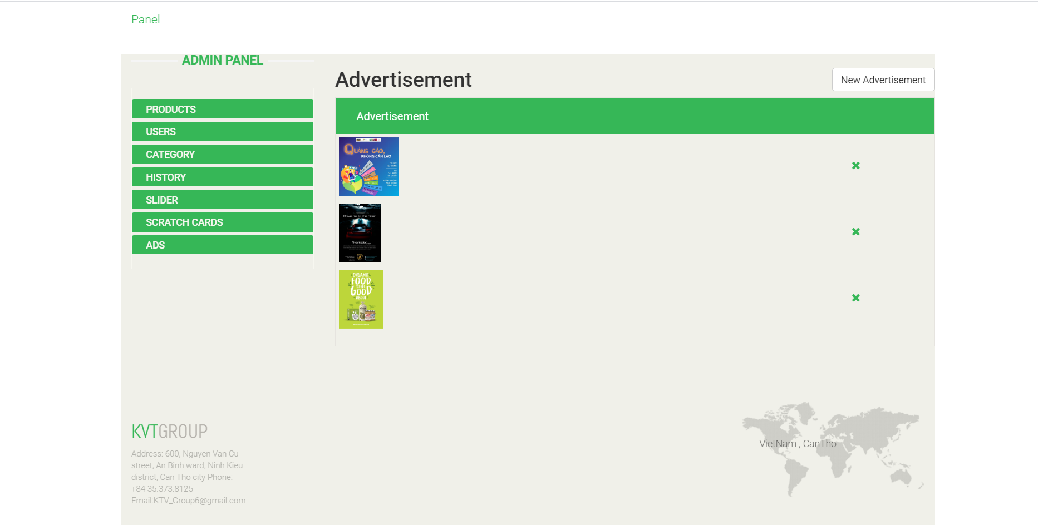

**Figure 25**: *Admin manage advertisement*

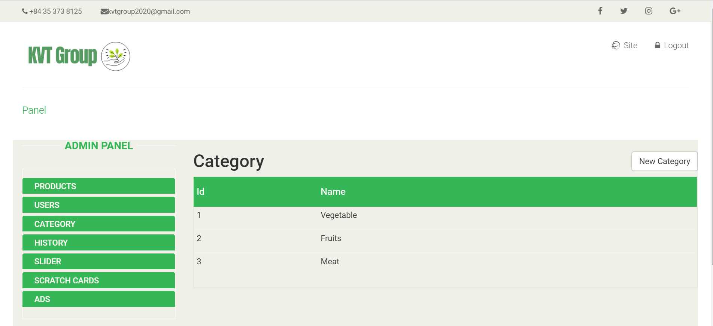

**Figure 25**: *Admin manage category*

1. **Conclusion**

This is to conclude that the project that I undertook was worked upon with a sincere effort. Most of the requirements have been fulfilled up to the mark and the requirement which have been remaining, can be completed with a short extension.

The project made here is just to ensure that this product could be valid in today real challenging world. Here all the facilities are made and tested.

In near future it will be extended for many types of features so that efficiency can be improved.

